**CDAC Mumbai**

**Lab Assignment: 1**

**Flowchart and Java Programming**

**Name**: *Akash Bhadane*

**Flowchart + Java Programming Questions: (use Notepad++)**

1. **Check Positive Number:**
   * **Task**: Create a flowchart to check whether a number is positive.
   * **Next Step**: Write a Java program that checks if a predefined number is positive using an if-else statement and prints the appropriate message.

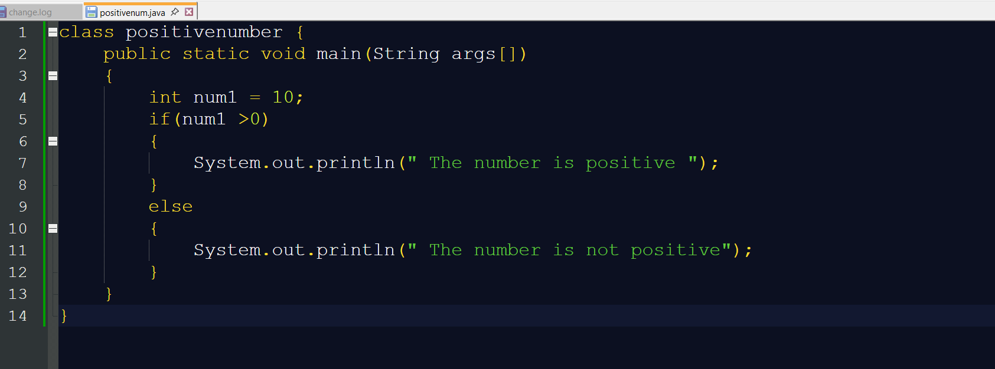

**Output:**

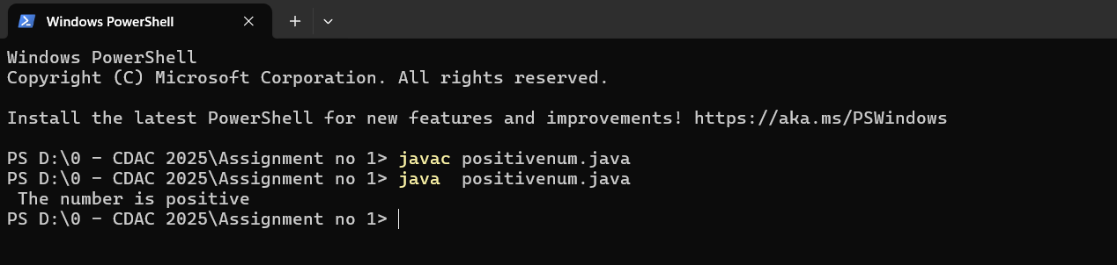

1. **Check Negative Number:**
   * **Task**: Create a flowchart to check whether a number is negative.
   * **Next Step**: Write a Java program that checks if a predefined number is negative using an if-else statement and displays the result.

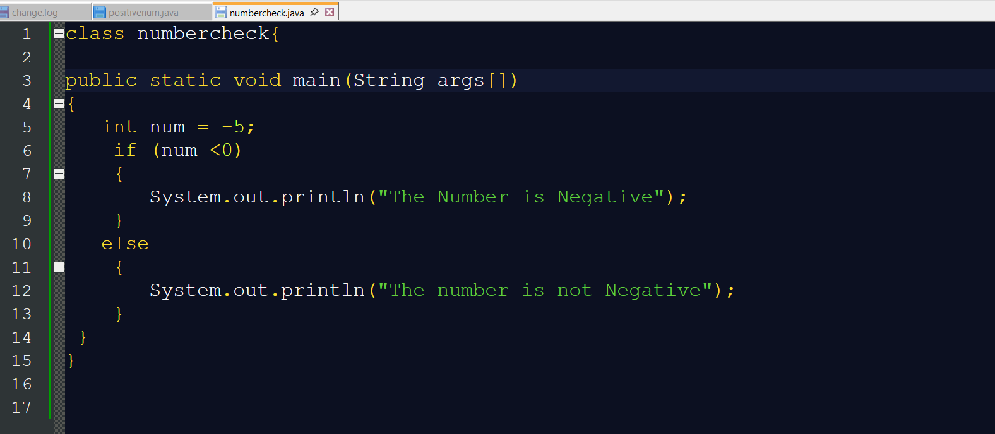

**Output:**

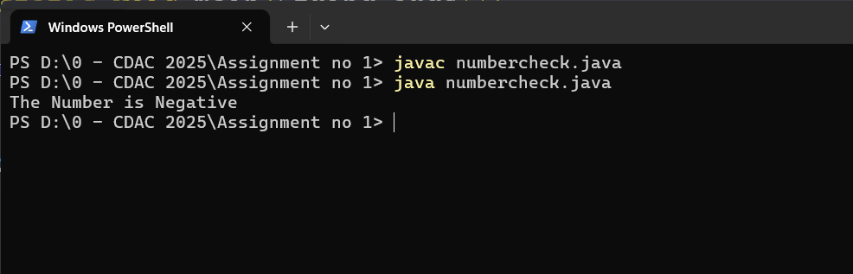

1. **Check Odd or Even Number:**
   * **Task**: Create a flowchart to determine whether a number is odd or even.
   * **Next Step**: Write a Java program that checks if a predefined number is odd or even. Use an if-else statement and the modulus operator (%) to determine whether the number is divisible by 2 or not.

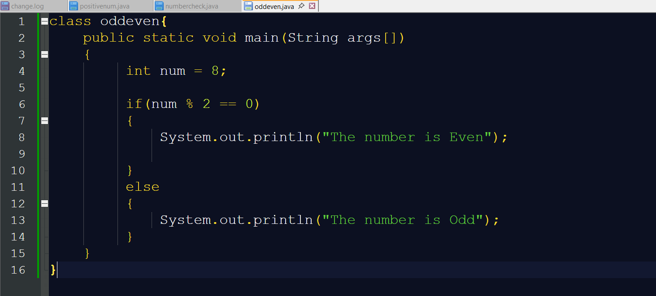

**Output:**

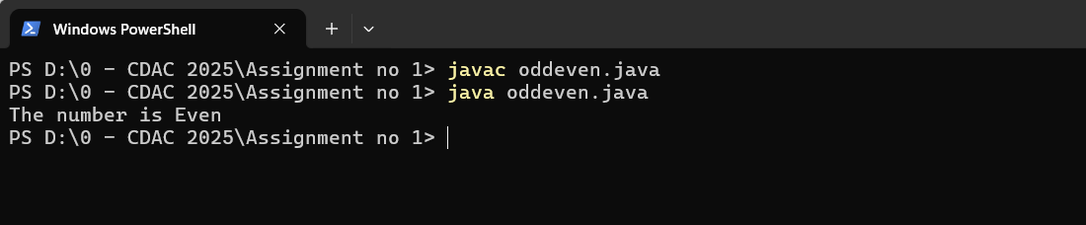

1. **Display Good Morning Message Based on Time:**
   * **Task**: Create a flowchart to display a "Good Morning" message based on a given time.
   * **Next Step**: Write a Java program that displays a "Good Morning" message if the predefined time is between 5 AM and 12 PM. Use an if statement to implement the logic.

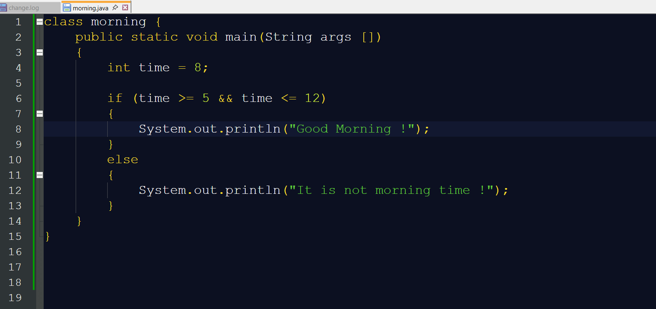

**Output:**

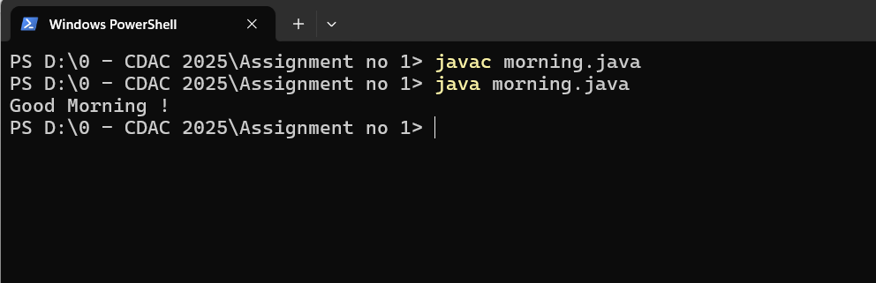

1. **Print Area of a Square:**

* **Task:** Create a flowchart to calculate and print the area of a square.
* **Next step:** Write a Java program that calculates the area of a square using the formula area = side * side. Use a predefined side length.

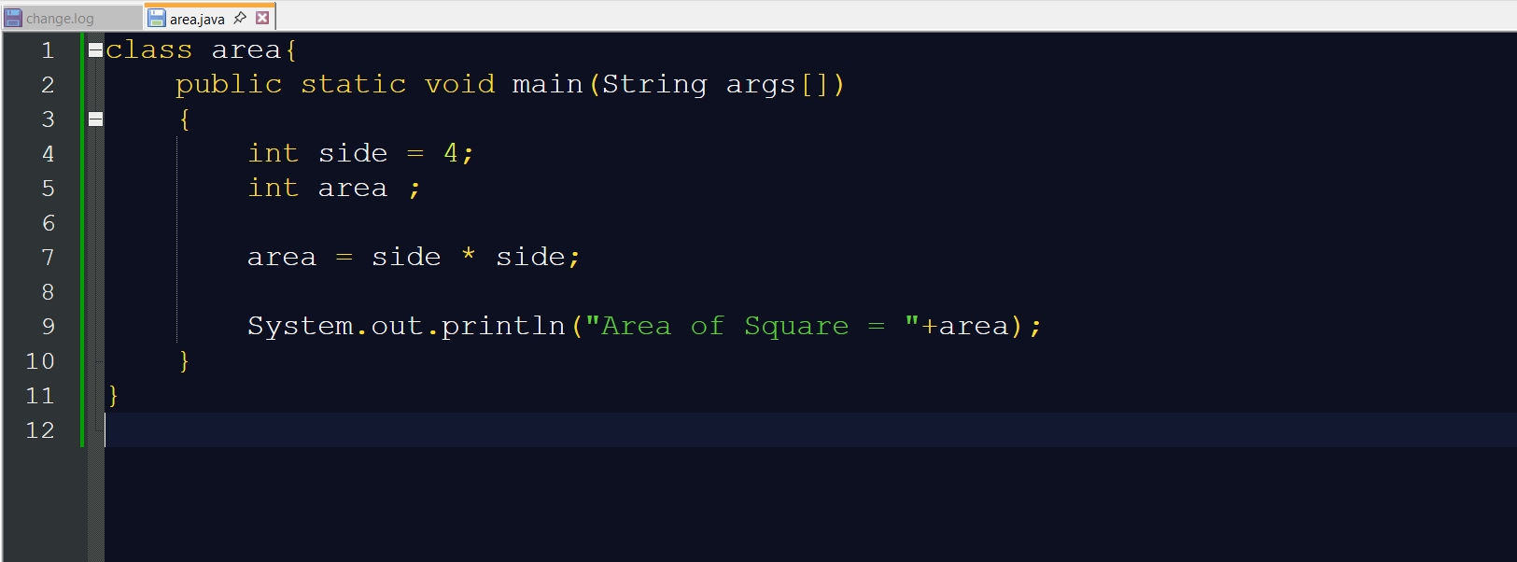

**Output:**

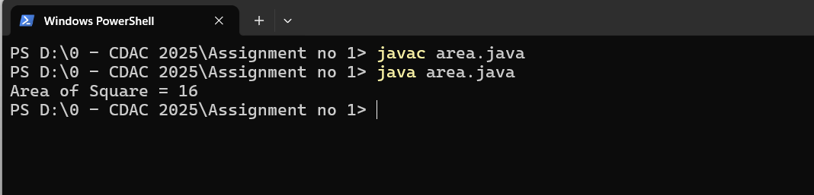

1. **Print Area of a Rectangle:**
   * **Task**: Create a flowchart to calculate and print the area of a rectangle.
   * **Next Step**: Write a Java program that calculates the area of a rectangle using the formula area = length * width. Use predefined values for length and width.

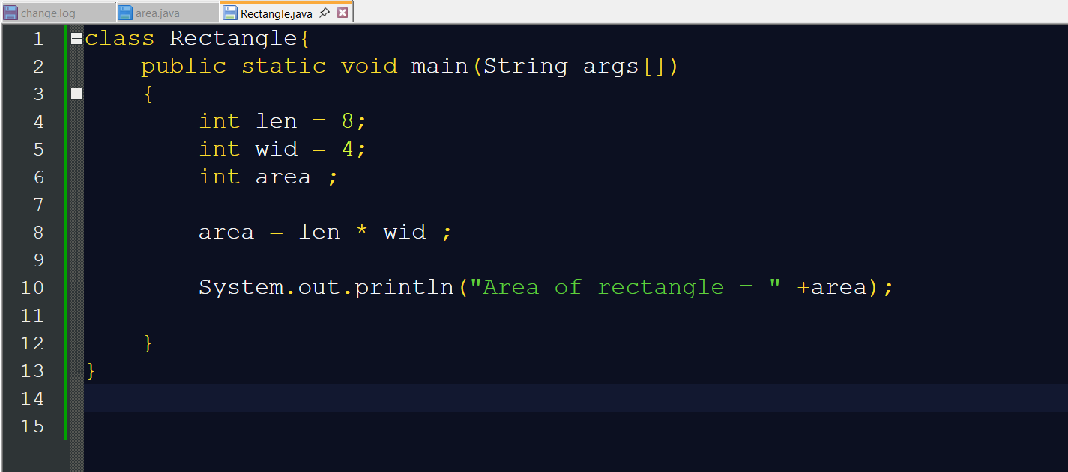

**Output:**

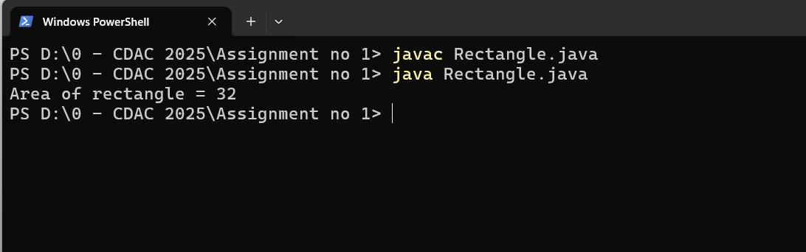

1. **Find the Largest of Three Numbers:**
   * **Task**: Create a flowchart to find the largest of three numbers.
   * **Next Step**: Write a Java program that finds and prints the largest of three predefined numbers using if-else statements.

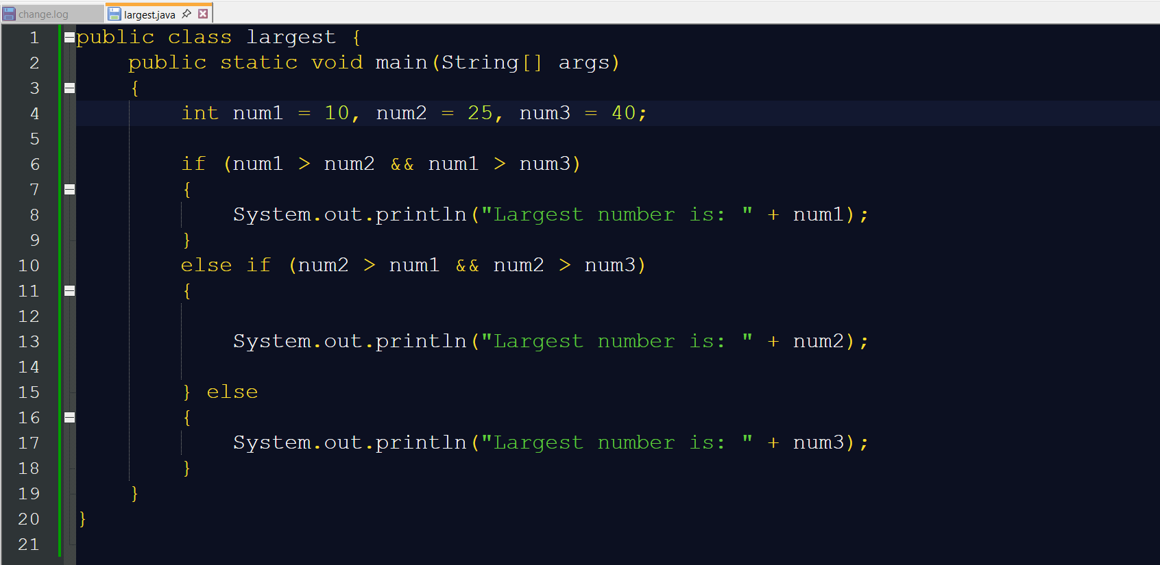

**Output:**

